**Worksheet 3.1 or 8**

**Student Name:** Vivek Kumar **UID:** 21BCS8129

**Branch:** BE-CSE (LEET) **Section/Group:** ON20BCS-809/A

**Semester:** 4th Sem **Date of Performance:** 08/04/2022

**Subject Name:** MPI Lab **Subject Code:** 22E-20CSP-253

**1. Aim/Overview of the practical:**

1. Mask the lower nibble of an 8-bit number.
2. Mask the higher nibble of an 8-bit number.

**2. Task to be done:**

Write a 8085 Microprocessor program to perform the lower nibble & higher nibble of 8-bit.

**3. Apparatus/Simulator used (For applied/experimental sciences/materials-based labs):**

1. 8085 Jubin simulator version 2 (Microprocessor Simulator)
2. Java (jdk/ jre1.8.0_321)

**4. Algorithm/Flowchart (For programming-based labs):**

**Algorithm to mask the lower nibble of an 8-bit number:**

1. Load the 1st data to the Accumulator ‘A’ from 1000 memory address.
2. Move the data from Accumulator ‘A’ to register B.
3. Load the 2nd data to Accumulator ‘A’ from 1001 memory address which is F0.
4. Do ANDing operation between Accumulator ‘A’ and Register B by Using ANA B.
5. Store the ANDed value from Accumulator ‘A’ to 1002 memory location.
6. End the execution using HLT.

**OR,**

1. Load the data to Memory from 1000 address using Immediate Instruction LXI H, 1000.
2. Move The data from Memory to Accumulator ‘A’.
3. Perform Immediate ANDing operation in Accumulator ‘A’ with ‘F0’ by Using ANI F0 instruction.
4. Store the ANDed value from Accumulator ‘A’ to 1002 memory location.
5. End the execution using HLT.

**Algorithm to mask the higher nibble of an 8-bit number:**

1. Load the 1st data to the Accumulator ‘A’ from 1000 memory address.
2. Move the data from Accumulator ‘A’ to register B.
3. Load the 2nd data to Accumulator ‘A’ from 1001 memory address which is 0F.
4. Do ANDing operation between Accumulator ‘A’ and Register B by Using ANA B.
5. Store the ANDed value from Accumulator ‘A’ to 1002 memory location.
6. End the execution using HLT.

**OR,**

1. Load the data to Memory from 1000 address using Immediate Instruction LXI H, 1000.
2. Move The data from Memory to Accumulator ‘A’.
3. Perform Immediate ANDing operation in Accumulator ‘A’ with ‘0F’ by Using ANI 0F instruction.
4. Store the ANDed value from Accumulator ‘A’ to 1002 memory location.
5. End the execution using HLT.

**5. Description/ Code:**

**Program to mask the lower nibble of an 8-bit number:**

# ORG 0900H

LDA 1000

MOV B, A

LDA 1001

ANA B

STA 1002

HLT

# ORG 1000

# DB D7H, F0H

**OR**

# ORG 0900H

LXI H, 1000

MOV A, M

ANI F0H

STA 1002

HLT

# ORG 1000

# DB D7H

**Program to mask the higher nibble of an 8-bit number:**

# ORG 0900H

LDA 1000

MOV B, A

LDA 1001

ANA B

STA 1002

HLT

# ORG 1000

# DB D7H, 0FH

**OR**

# ORG 0900H

LXI H, 1000

MOV A, M

ANI 0FH

STA 1002

HLT

# ORG 1000

# DB D7H

**6. Result/Output/Writing Summary:**

**Output to mask the lower nibble of an 8-bit number:**

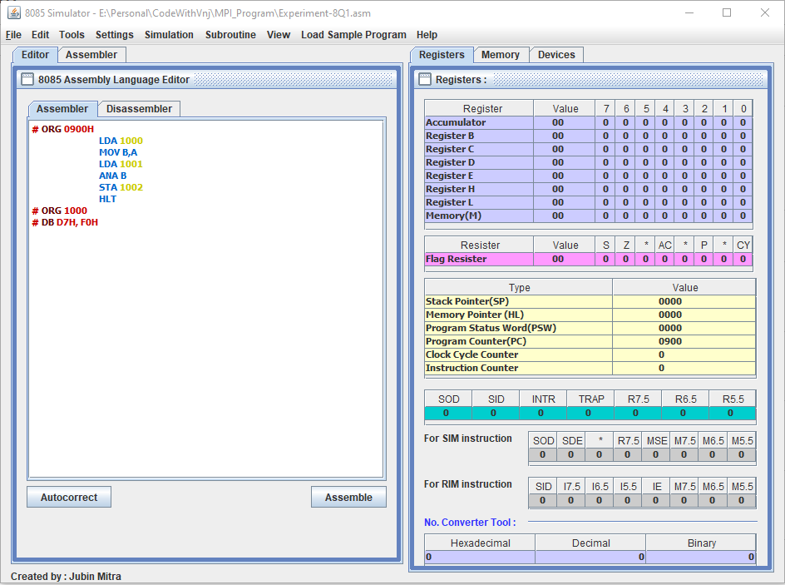

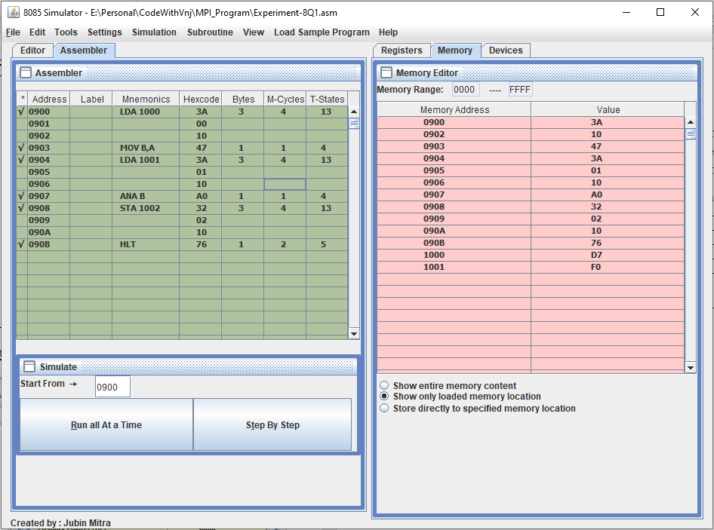

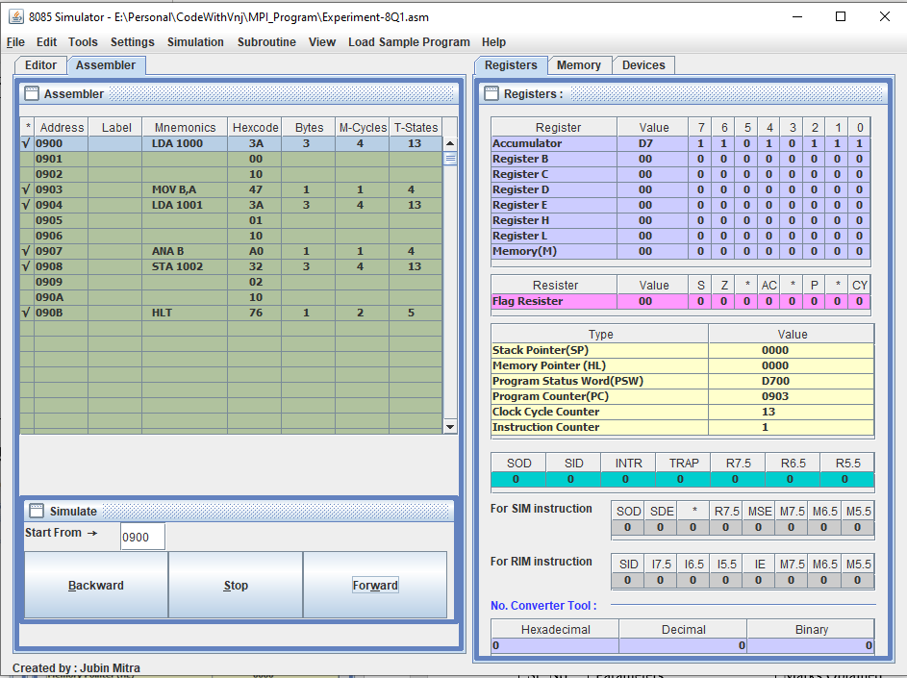

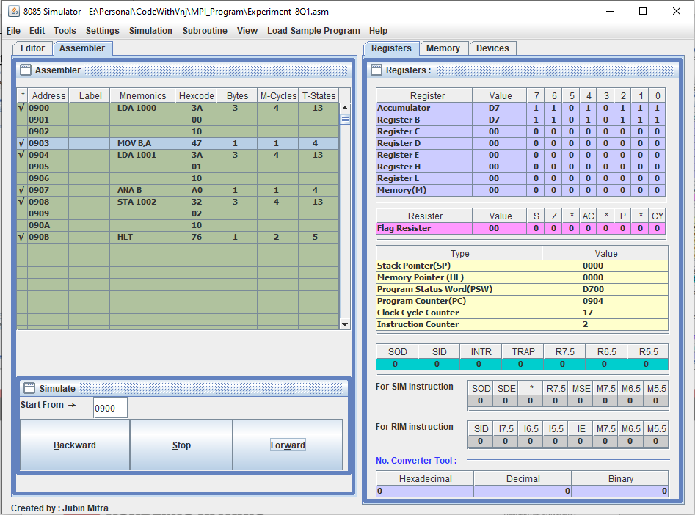

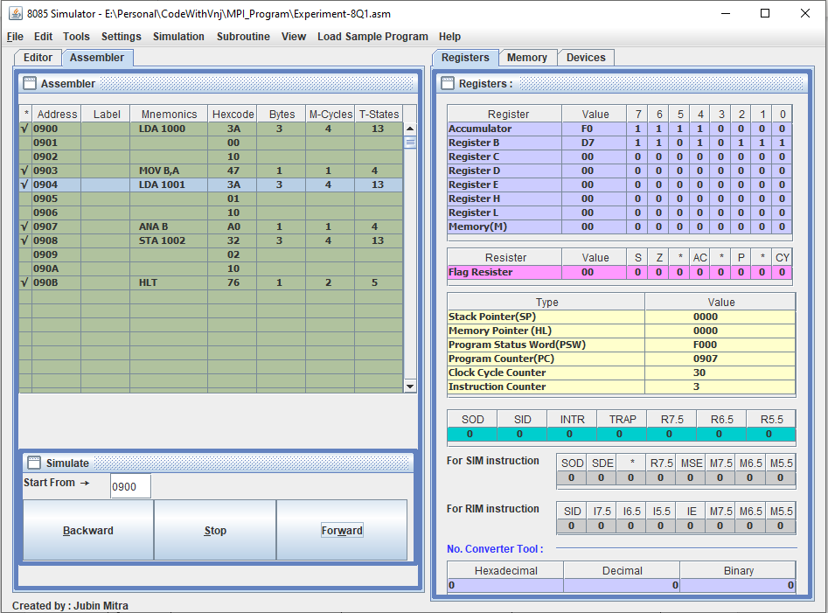

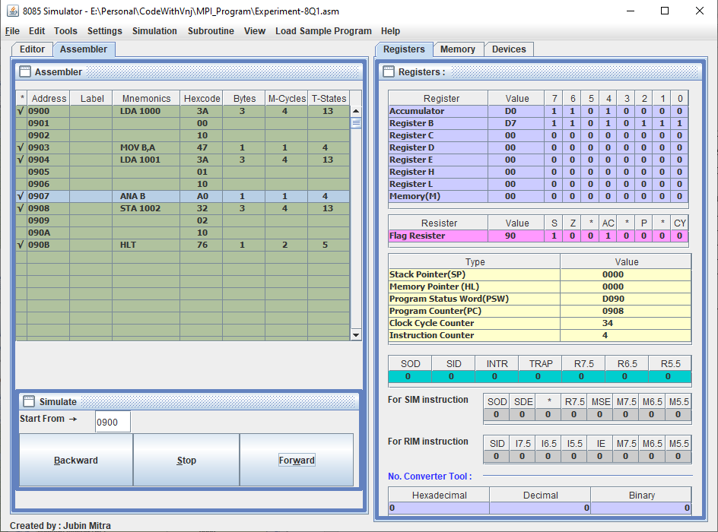

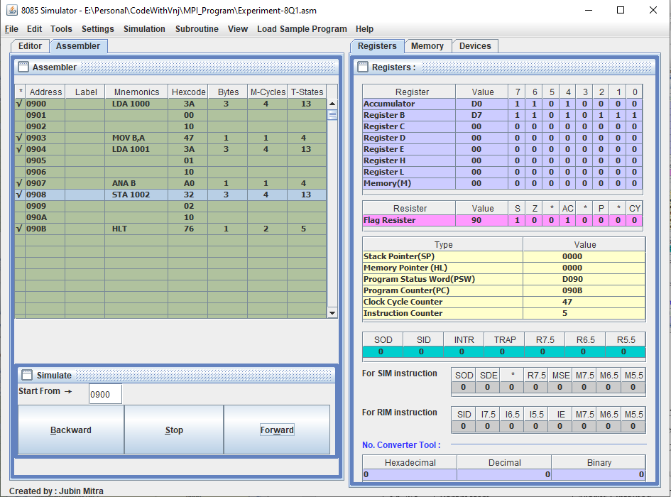

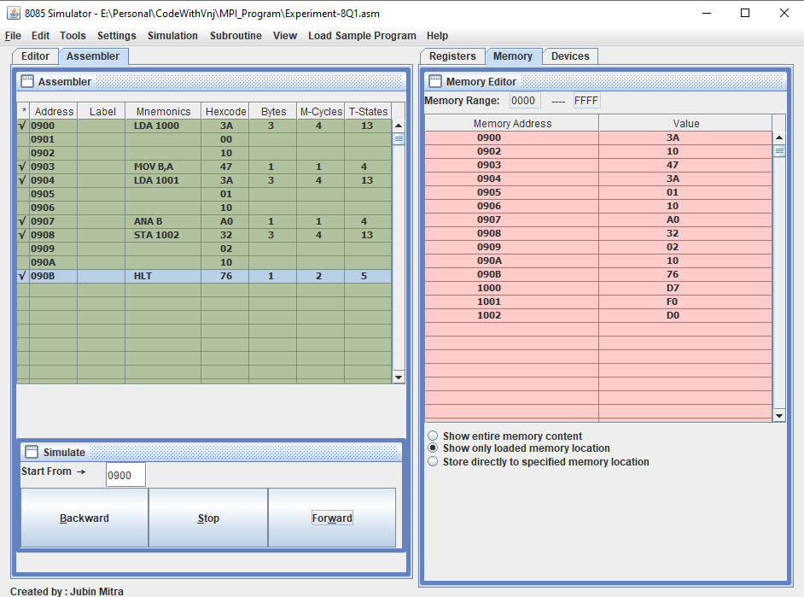

**OR**

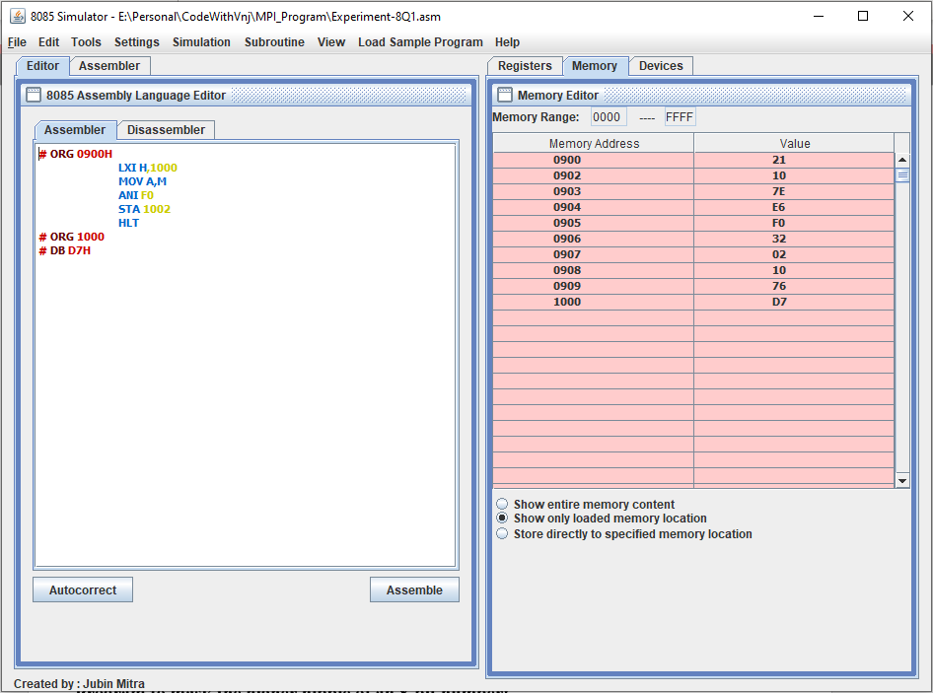

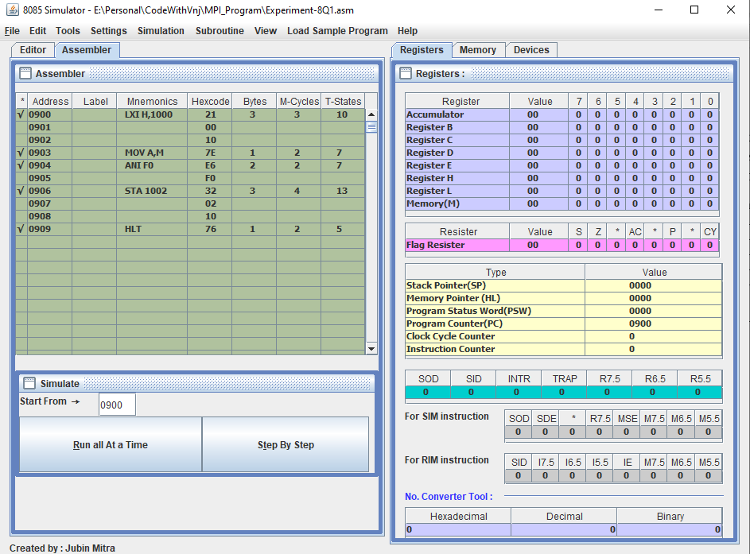

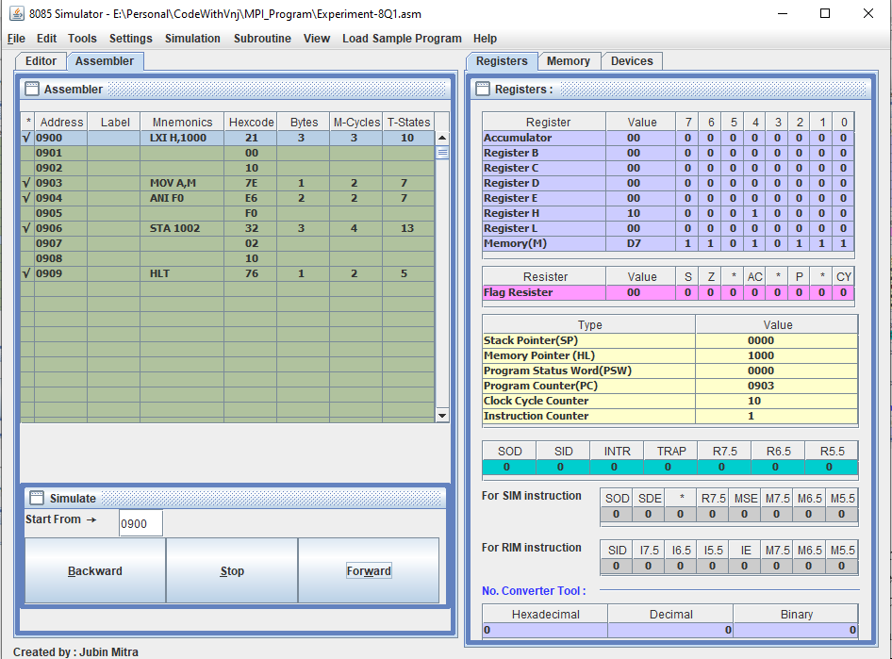

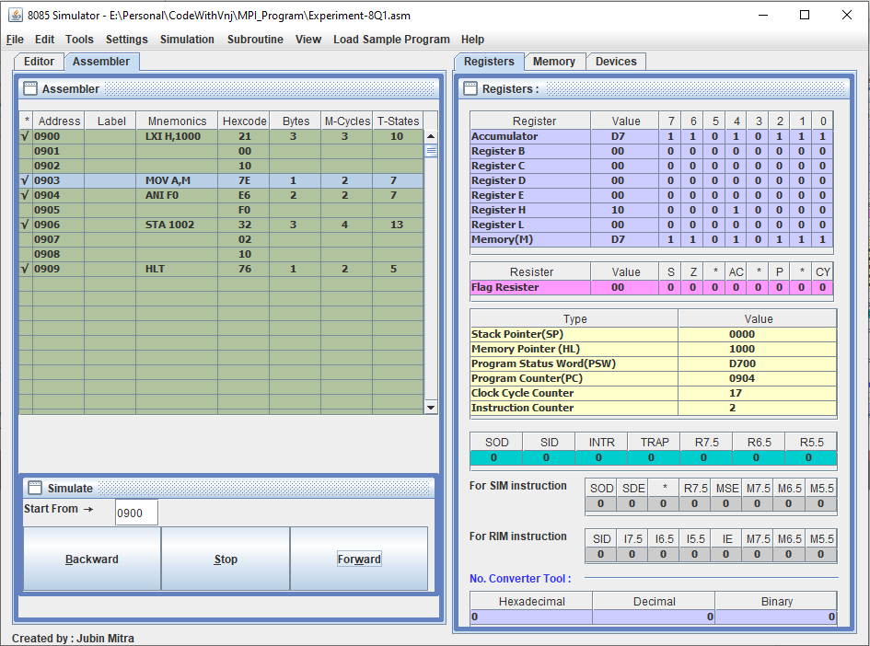

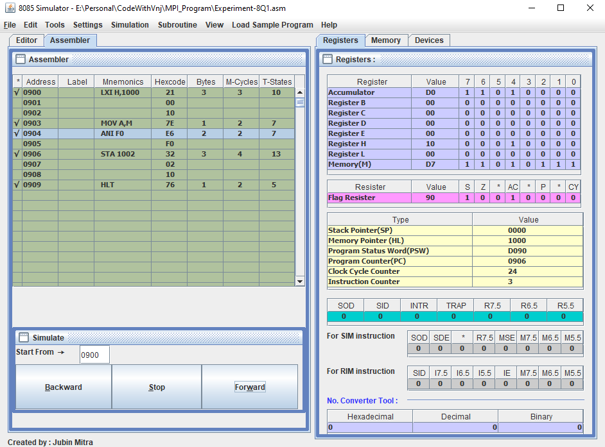

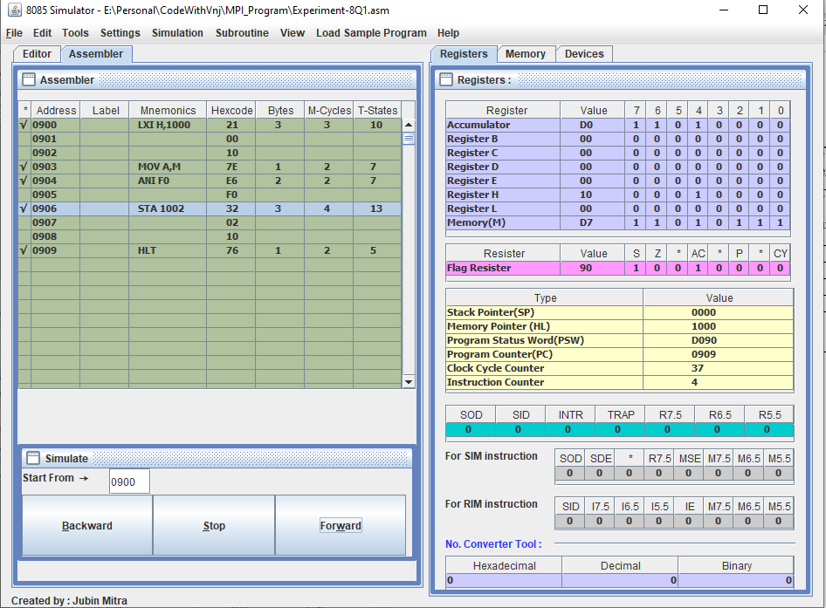

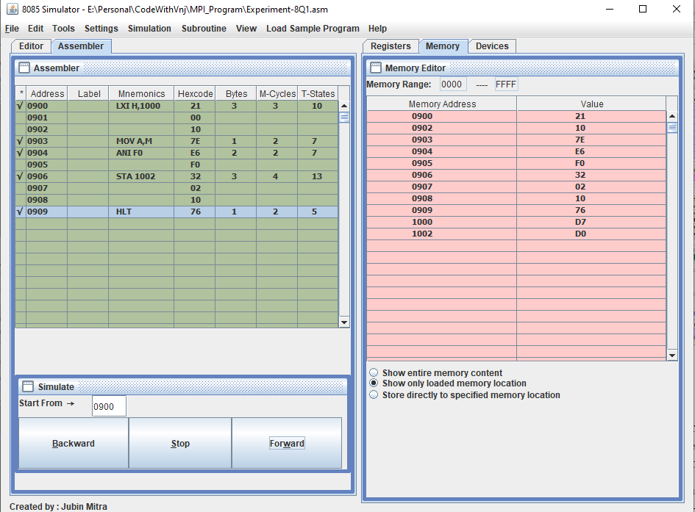

**Program to mask the higher nibble of an 8-bit number:**

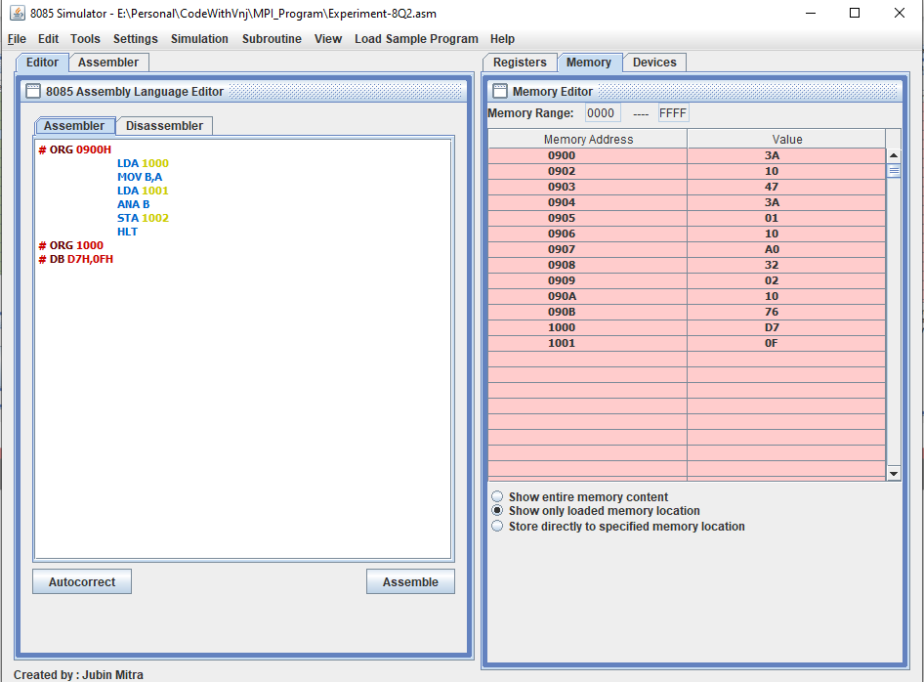

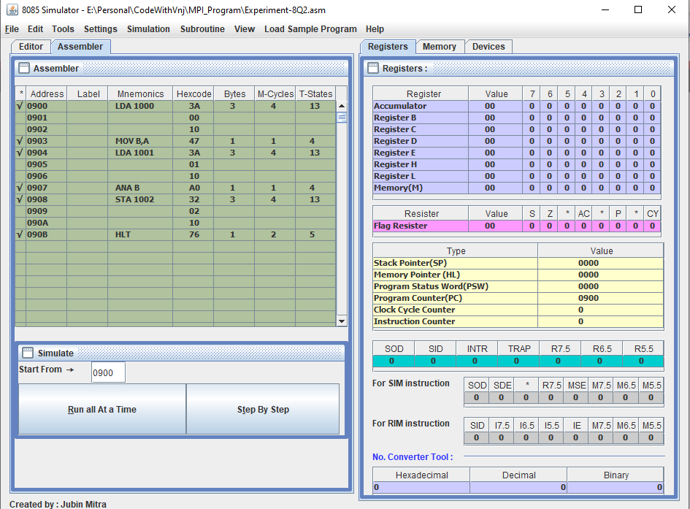

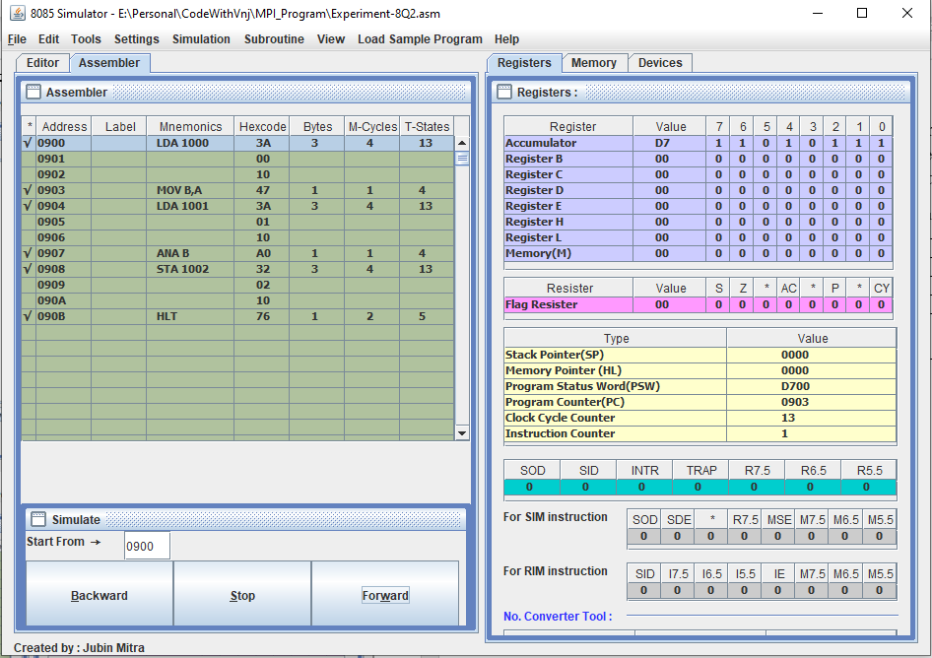

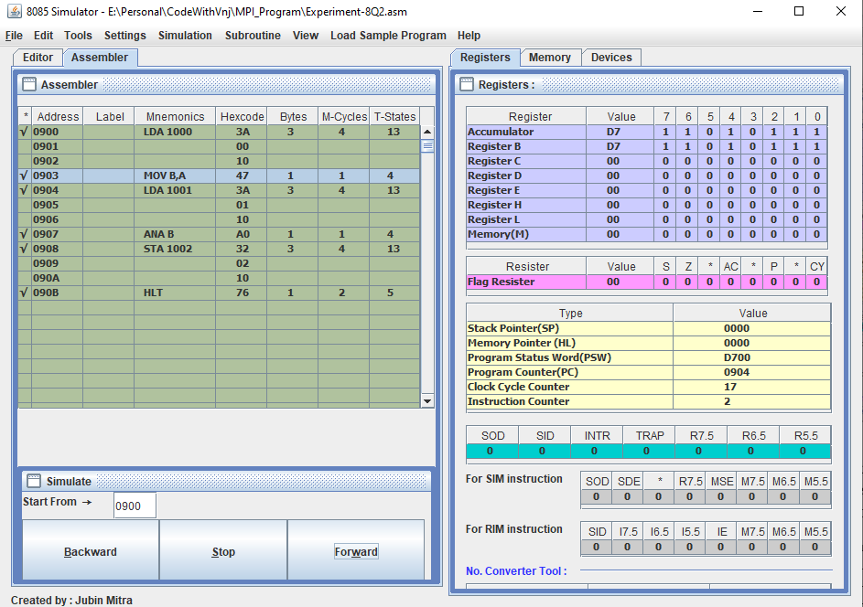

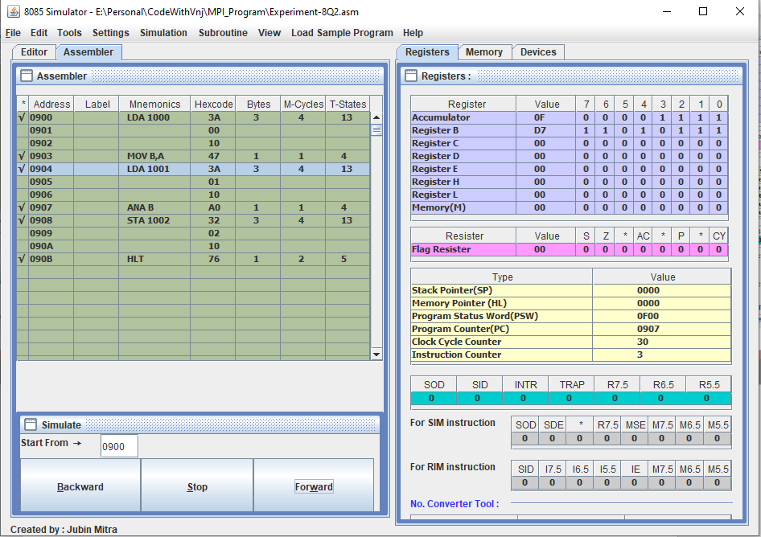

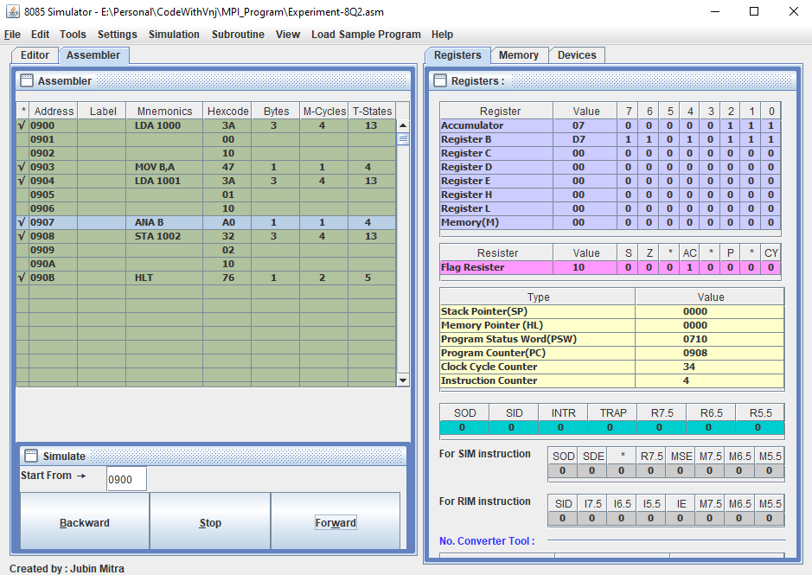

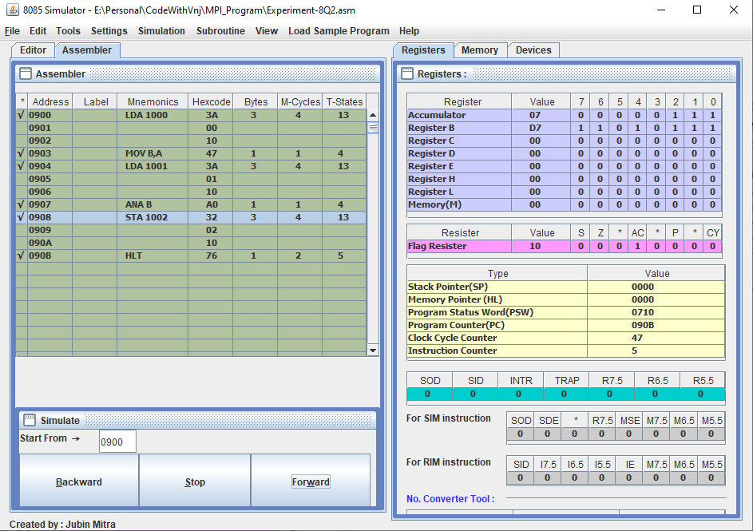

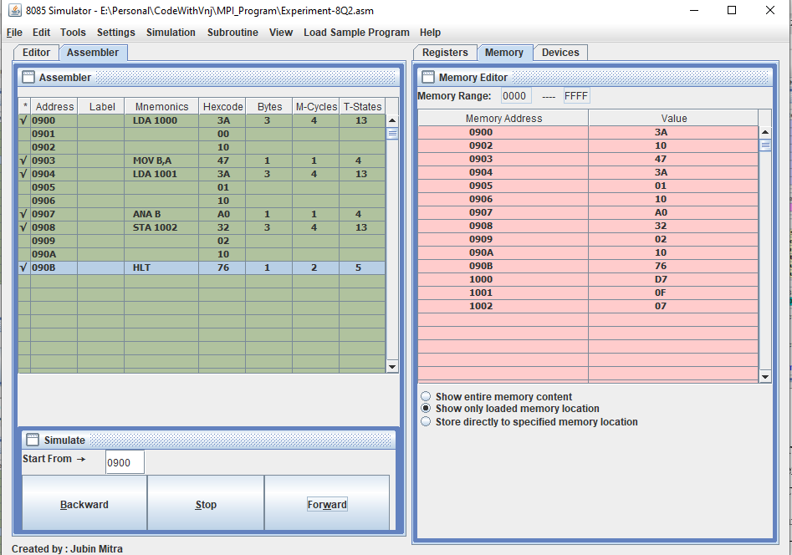

**OR**

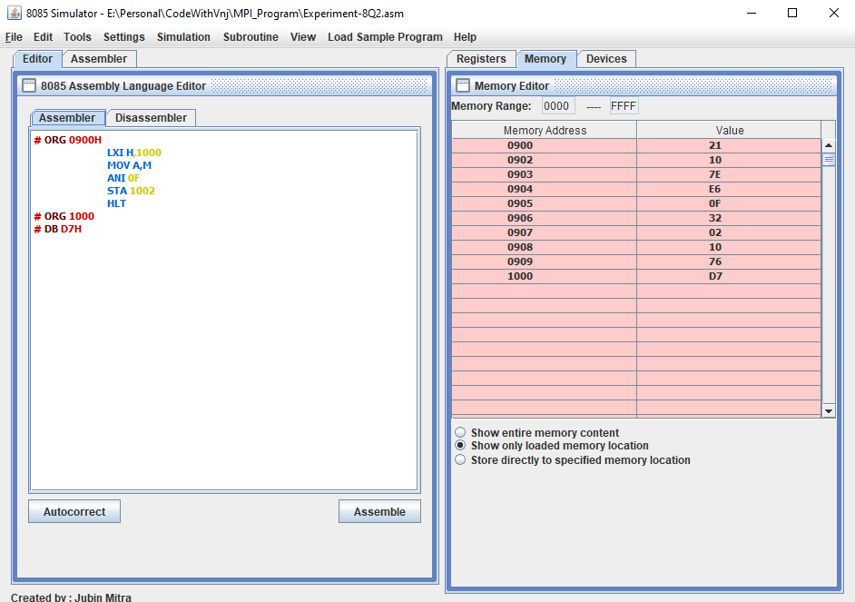

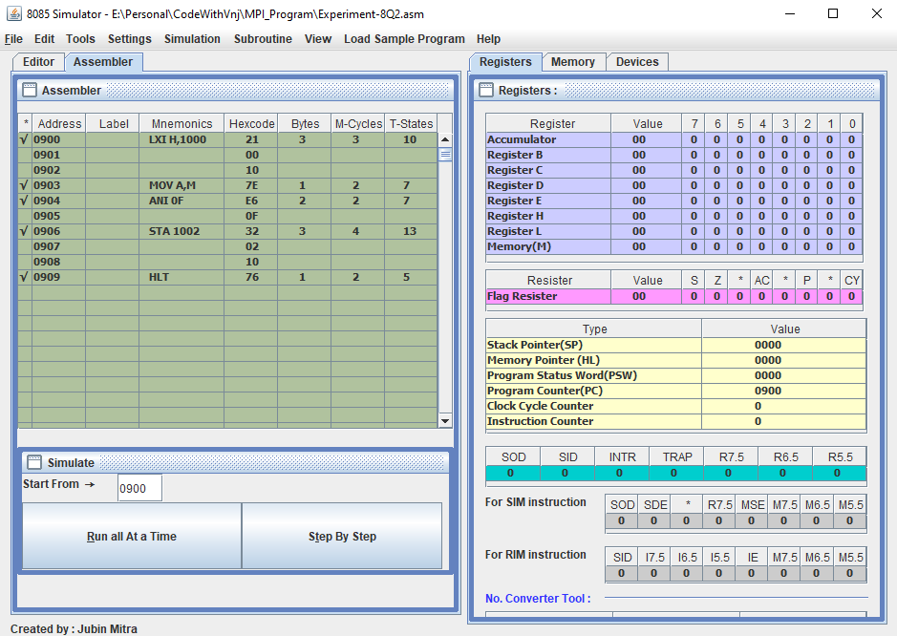

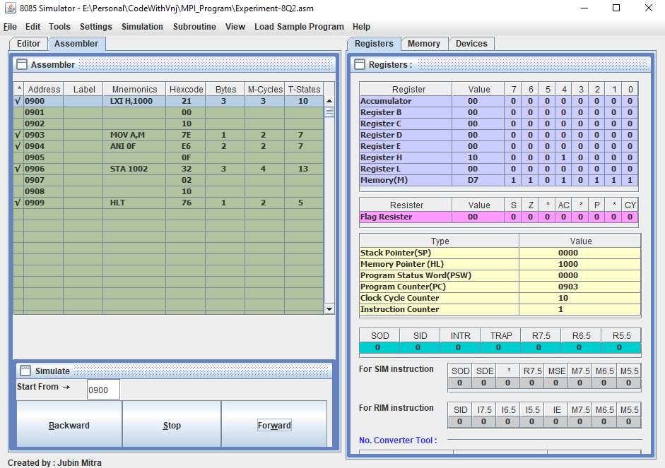

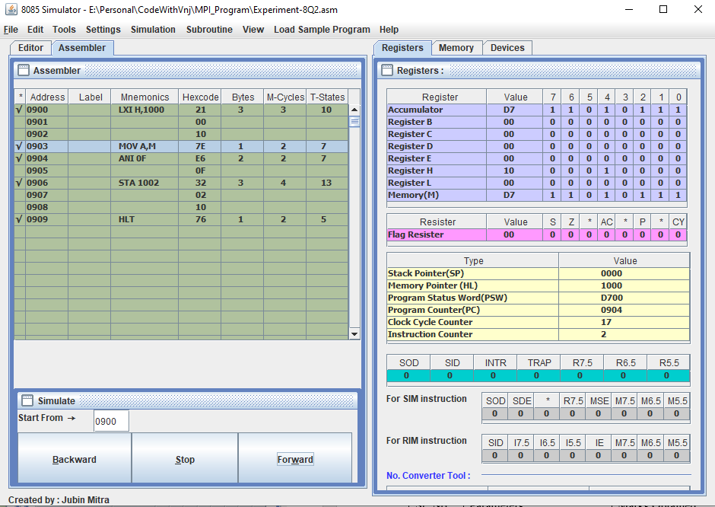

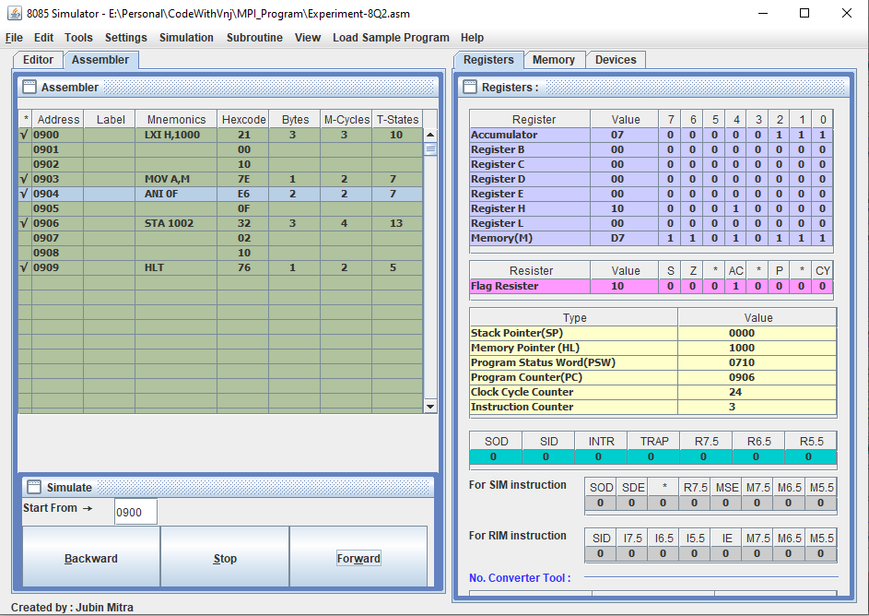

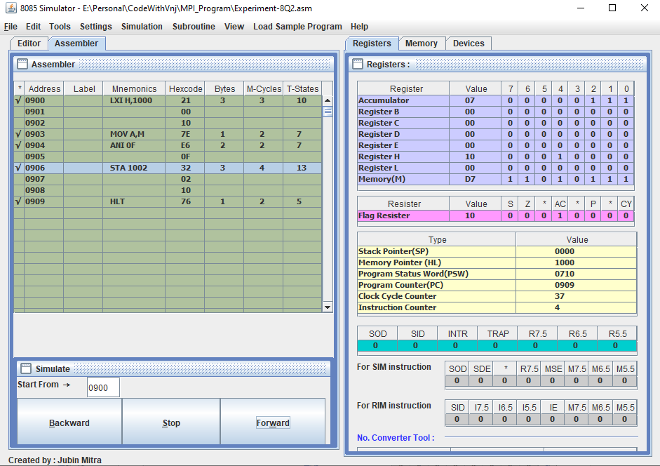

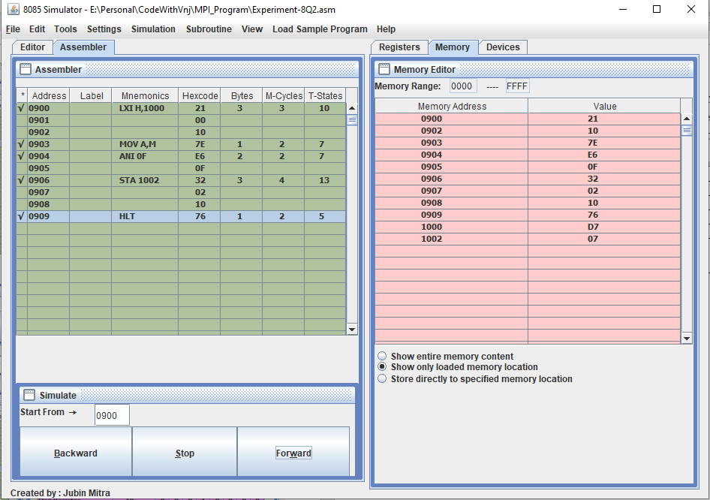

**Learning outcomes (What I have learnt):**

1. Learnt to mask the lower nibble of an 8-bit number.
2. Learnt to mask the higher nibble of an 8-bit number.
3. Learnt to perform the ANDing operation between two 8-bit number.

**Evaluation Grid (To be created as per the SOP and Assessment guidelines by the faculty):**

|  |  |  |  |
| --- | --- | --- | --- |
| Sr. No. | Parameters | Marks Obtained | Maximum Marks |
| 1. |  |  |  |
| 2. |  |  |  |
| 3. |  |  |  |
|  |  |  |  |